West Hull Ladies
RRC

September Newsletter

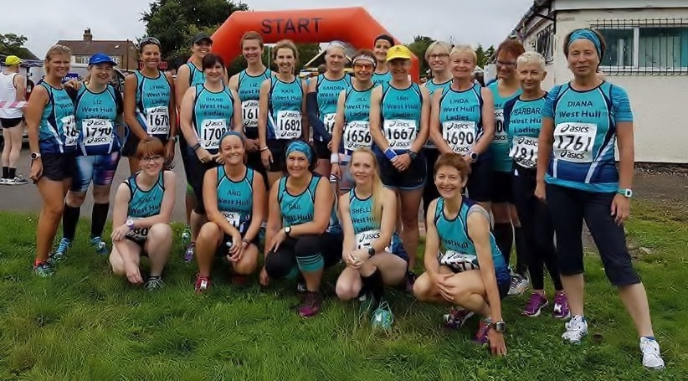
21 ladies at Gilberdyke Ten Miles
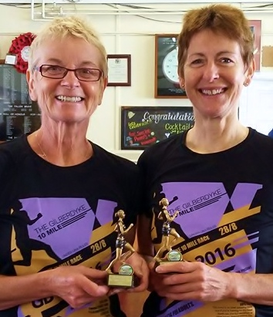

Linda and Amanda
with trophies

1st in age groups

West Hull Ladies
Committee Meeting Minutes

05/09/2016

Present: Amanda, Linda, Shelley, Maria, Anna, Jill.
Apologies: Annette, Jan, Liz, Sandra, Karen.

The committee agreed the minutes from August.Matters arising were moved to the next meeting as the Chair had forgotten to bring the minutes to the meeting (sorry).

Issues discussed:

Hill Training: Jane asked whether it would be possible to have a second hill training session in the month, either on Monday or on a Friday. This was considered but it was decided that it would be a shame to lose one of the sessions on Monday as all of these are popular with club members. In terms of Friday, it was decided that the Friday interval training worked well as this was both inclusive for members of all speeds and was a good session to have before the weekend as it was short and not too demanding, which was good because many runners like to take part in parkrun and other events over the weekend. The other problem was that if we took another session away from the club base, that runners who did not have access to transport would not be able to take part. It was also highlighted that for the foreseeable future up until December, the club would be organising Recce’s for the Rudolph Romp on most Sundays, which would represent an excellent opportunity for Hill training. For these reasons it was decided to not proceed with a second hill training session at this time, but the committee is always open to suggestions for new sessions and will consider them accordingly.

Hull Marathon Update:
Andrea has reported that she has got enough people to run the water station, and there are a number of others helping elsewhere on the day. WHL runners are welcome to leave a drink with their name and approximate time of arrival (at 9 miles) on the WHL water station. Amanda is to ask Andrea how people should get drinks to her on the day and this will be advertised via the club email.

Goody Bag packing:
Amanda is collating names of people who will help with the goody bag packing on the Thursday before the Marathon. Amanda to remind people by email about this.

Marathon social events:
Shelley talked about a couple of social events to celebrate the marathon. Shelley is to publicise details of these on facebook, and compose an email to be sent out via the club email.

Marathon teams:
Hopefully all the team members will be fit to run the event on the day, however it was mentioned that Suzanne would be willing to join a team if any of the team members could not run for one reason or another.

AOB:
There were a number of things mentioned in AOB. Amanda reminded us about the Tired of being Tired seminar: Amanda to prompt members about this event by email and facebook.

It was also mentioned about the ‘Apple scam’ that had reached a number of member’s emails and the need to remind members to be vigilant about these scams. Amanda offered to compose an email to give members some tips on how to protect themselves and also to change their passwords frequently.

The matter of Emails that come to the club about other events that members might be interested in was discussed, as these are usually sent to the committee to pass before sending out to members. The example was given of the recent call for marshals for an event in Rochdale. It was suggested that in most cases, it might be better to send these straight out to members unless the email was seen to be problematic in some way, rather than sending it to the committee first.

WHL Weekend away at the Dalby Pods:
Rachael L suggested that we might want to organise a weekend away in Dalby forest at the Dalby Pods to do some trail running and the Dalby Forest park run. These are camping type pods (heated) which would take up 20 people in 5 pods. She found out some suitable dates in October and November when the pods were vacant. The pods cost £40 a night and sleep 4 people. The committee identified that 11th /12th November might be a good weekend as the Dalby Dash 10k race was taking place on 13th. Jill to put out an email and facebook message to advertise the idea and determine interest.

Meet a Member : Carol Holmes

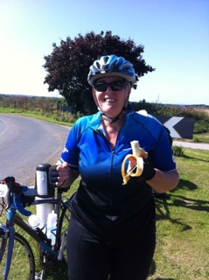
Age 59

Member of WHL since – April 2016

What do you do when you’re not running? – (work/hobbies/family)
When I’m not running I look after my lovely wife Ann and son Anders. I walk Dixie my adorable dog and constantly see to the needs of the cats. My work life involves guiding and assessing social work students while they are out on their work placements.

How long have you been running? – My mum also said I could run before I could walk so I guess I’ve been running all my life (with long gaps!)

Why did you start running? – I have recently started running again because I have put on a lot of weight and become uncomfortably unfit. As I get older I realise that health is not something that just happens you have to work at it.

Favourite distance – Running is a struggle for me with my extra weight so I can’t say any distance is a favourite although when I was younger and a more serious athlete I was a 100m sprinter – could never do distance !

Favourite bit of running kit – WHL vest and my Brookes trainers

Any injuries? – Keep getting calf niggles

Running goals? – Just to carry on running and beat my Park Run PB

Proudest moment running related or otherwise – After the 0-5K I completed Park Run without having to stop and walk. Every time I go out running when I really don’t want to it’s a proud moment.

Best piece of advice you’ve received – Don’t stop-even if you have to walk

Running alone or with friends? – Friends

What keeps you motivated? – Life is my motivation, as many of you know we lost our daughter Daisy nearly 3 years ago now, this taught me to not take things for granted; particularly my health, I want to live for as long as I can and maintain my independence, this requires health and fitness and a certain amount of good luck!

Meet a Member : Oliver Dogsworth

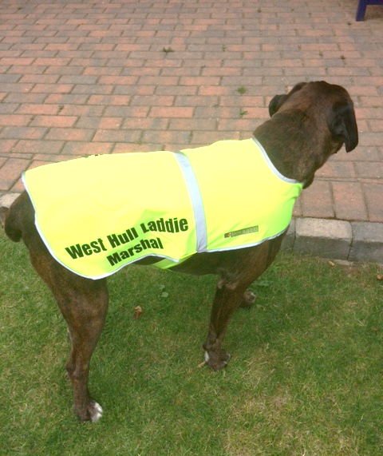

Age 6 years old
Member of WHL since – 3 years
What do you do when you’re not running? – I eat, take my Mum and Dad for Walks and play football in the garden.
How long have you been running? – I’m only a jogger because I can’t run too far
Why did you start running? - Because my Mum made me.
Favourite distance – Park Run
Favourite bit of running kit – My Yellow vest with West Hull Laddie Marshal on it
Any injuries? - Yes I have arthritis in my back knees and so can’t run too far
Running goals? – To beat Mum up the hills (I always do)!
Proudest moment running related or otherwise – When everyone claps at park run while I marshal.
Best piece of advice you’ve received – Stop when you’re out of breath (I always do then trip Mum up)!
Running alone or with friends? – I like to jog with Mum, I’m not allowed out on my own.
What keeps you motivated? – My dinner!
Gilberdyke ten miles : Ann
This was meant to be peak weekend for me - three weeks away from Hull Marathon, this was the weekend for my last long run. Therefore I wasn’t quite sure how to play this disruption to my plan - I’m a bit of a stickler for plans! I decided to take off and just to see how I felt, and if I could stick to 8:30 then that would give me a PB, and then if I did my 20 miler a couple of days after, then job’s a good ‘un.
It was a great atmosphere - so good to see so many folk there, and so many WHLs. I hadn’t raced since the final Champagne League, and hadn’t managed to get to any club training apart from Wednesday track sessions, so it was lovely to be with 'my people’ again.
Queue / loo / queue / loo / queue / loo (ok toilet blocked by this point, so this last visit was a bit more of challenge) - RUN!
And off we went - flat, they said, and it was, apart from a railway bridge at the beginning. As usual the pace was pretty optimistic, and I thought I’d just go with the flow and then see what happened. Inevitable I settled a bit, chatted to Sandra and Linda a bit, and then pushed on for my PB attempt. I didn’t want to go much faster than 8:30 miling, so I was looking at my watch a lot in order to maintain an even pace.
3 miles in and the first water station, and there was Debbie Smith, a White City Runner, and colleague, who beat me at every Champagne league race. I started to catch up with her, to my amazement, and after a little comment, I overtook her. A few seconds later I heard rapid footsteps behind me. She’d caught me up, started chatting - Chatting?? and then overtook me, properly overtook me. I let her go, I knew my place, and I kept my pace.
And so the miles came and went. I enjoyed the route, pleasant scenery and some encouraging comments from the locals as we ran by. After half way I was certainly working fairly hard, but still sticking to my 8:30 plan.
But then who should appear ahead but Debbie!! I began to reel her in … bit by bit I caught her up, and then snuck past. No comment this time, I had no spare breath for that!
At mile 6 I spotted Kate, and wondered how long before I caught her up as well. It took a full mile to catch her and then the last target was Jill Jameson herself. I could see her, and I knew I was gaining, but wondered whether I had enough race left to catch her up.
This was the best, and hardest part of the race. Very, very gradually I started catching her up, and by the time we got back to the railway bridge I’d caught up with her. That bridge was steeper from this direction, and took the wind right out of my sails, yet Jill sailed up it (did you like what I did there?!!). No worries, thought I, I’m good at downhills, I’ll get her on the other side, but the slope wasn’t as steep as I wanted, and I was still reeling from the little climb. But I kept at it, and managed to catch her up again, but here was my fatal error. With about half a mile to go, and overtook her, and tried to pull away, but I didn’t have enough left to get away, and she was too strong for me. She stayed with me, overtook me, and, well, took off.
I’d never had such a race to the finish before - it was good fun, racing a friend like that. Well done, Jill - but next time I’ll sit on your heel and then snatch it from you in a sprint finish at the very end.
I’ll get you, my pretty!!!!
Oh yes, and in case anyone else fails to mention it - you MUST do this race next year, because the flapjack and cup of tea at the end was worth running 20 miles for :)
Ann
Gilberdyke ten miles : Amanda

I was looking forward to this race. I had a good one at Escrick. I was feeling strong and there was excitement in being part of a new event. I knew the route well as 8 miles of it is a regular cycle time trial which is run by Hull Thursday.

I cannot run a race without giving myself a target time/pace but it had been years since running a 10 mile race and I have become slower over the past 2 years so not sure about what to go for. I gave myself some slack and aimed at 73 mins (Ferriby 10 PB=72 mins which is much harder).

Was amazed at how many club ladies were on the start line. Good to have Sports Timing as I know they do a good job and everything was well organised.

Off we went and of course I went too fast running my first mile in 6:50 but I then settled in to 7min/mile for the next few miles which was spot on. Good to get some cheering in the villages but by now I was slowing. Really annoys me when this happens I am so rubbish at pacing myself. Had a real dip from 6 miles but around 7.5 miles I felt strong again. Not sure I went faster but I found it very easy mentally to push the miles on and passed a few runners. The bridge loomed and I enjoyed pushing up it and sailing down the other side. I was starting to feel the effort and stop enjoying it but it was not far to the finish. Under the finish in 74 mins! I am going to have to lower my self-expectations even more!

I checked the results and found I was 1 out of 1 in my age group. Baffled I said only one! The guy next to me said “you’re the first one back in your age group.” Duh, I can be so stupid.
Time to watch and cheer Lynne in next then Jill very pleased with her time. Linda came in “check your position Linda”. I can’t see she said. So I dragged her to the result check and there she was 1st in age cat and she was very happy.

The T Shirt was fantastic – it fits! The cup of tea was fabulous. The flapjack was amazing. And wonderful to get 1st in age group with Linda.

Very much recommend this race ladies.

Lincolnshire Wolds Tough 10: Linda

It was touch and go whether this race went ahead or not, thankfully it did because it is one of my favourites.
It is hilly and I mean hilly, in fact two of the hills are on the same scale as a mountain (well it sure feels that way).
There were no other WHL taking part as it is Major Stone half the next day and lots had opted to do that. But I was doing this as part of my training schedule which said 70 minutes of running on a hilly route, I knew I would more than cover that during this 10 miles.
When we set off the weather was lovely, not too sunny, not too windy and not too hot, perfect running weather. I settled into a nice rhythm and concentrated on my style, breathing and trying to keep an even pace. Although the even pacing soon went out the window when we came to the first big hill! But the downhills were great and I zoomed down those in Amanda style (just as she taught us).

When we reached mile 7 it became cloudy and I could feel spots of light rain but I was thankful because I was beginning to overheat (yes you heard right, Linda overheating – that has never been said before)! Mile 8 and rain was steady, mile 9 and it was chucking it down. The last mile had a nasty hill but then it was downhill right until the finish. Thankfully as by now I looked just like a drowned rat and I was freezing (that’d be normal then)!
It was strange not having anyone there either at the finish already or waiting around to cheer our ladies in, I felt a bit lost as most people had just jumped in their cars and gone home.
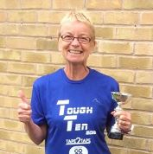
I wandered over to the timing people and found out that I had won 1st FV60 so I got a lovely trophy. I was dead chuffed as I’d won 1st at Gilberdyke the Sunday before, so two trophies in just less than a week.

You won’t believe this though ladies, my time at Gilberdyke 10 was 1:27:18 and my time at Tough 10 was 1:27:18 which is over a minute faster than last years, but how on earth did I manage to get the same times over two very different courses! Next year at Gilberdyke I must try harder to beat that.

Running Fuel: Recipe Corner

Green chicken curry (hariyali murgh) : Ros
I thought that this would be a nice recipe to share, especially for those who have a marathon soon as I find I don't have much appetite after a marathon. I make up for it the next day! But after a race I know I need to eat properly in the evening and I find that I can eat a curry, I think it's the spices!

This recipe takes about 20 minutes to cook and you can make the sauce the day before. Serves 4

The sauce:
350g natural yogurt (not thick set)
Large bunch of fresh coriander - leaves and stalks
Handful of fresh mint leaves
Lump of fresh ginger, peeled - roughly 20g or 3cm
4 cloves of garlic
2 green chillies - adjust to your preferred spice level (it's not a hot curry)
1 onion
In a food processor add: peeled onion, garlic and ginger, chillies, herbs and yogurt. Blitz until lump free. It's a runny sauce and you can make this the day before and keep in the fridge.

For the curry:
8 skinless, boneless chicken thighs - cut into chunks
2 heaped teaspoons of ground coriander
1 teaspoon of ground cumin.
In a large sauce pan, heat coconut or rapeseed oil, both have high heat points which is good for browning the chicken.
Brown the chicken. You can then add any veg you want. I tend to add frozen sliced peppers, sliced fresh mushrooms and frozen peas. These cook quickly and don't take long to prep. Turn down the heat so it will simmer once sauce is added. Add the sauce and ground coriander and cumin and simmer for 10-15 minutes, until the chicken is cooked.

Serve with brown rice. It's also nice with rice noddles or chips!

The curry sauce also works really well with white fish, such as pollack or hake and is even quicker to cook. Brown off any veg first, add the sauce and then raw fish. Cut into chunks and the fish will cook in 5 minutes. The sauce also works with sweet potato and chickpeas.
Ros

2016 RACE DIARY

Free 5K time trial every Saturday 9am:
Hull Parkrun Peter Pan Parkrun Humber Bridge parkrun

Double check dates, times and entry fees with the official website or the entry form. Zx Website contains all the links to the races: http://westhullladies.org.uk/races.htm

September 2016
 | 4th/10:00 | Major Stone Half Marathon | £18.70 UKA/£20.70 | Online entries only | Online entry
 | 4th/11:00 | Tholthorpe 10K | £10 UKA/£12 | Entry form | Online entry (+£1.40)
 | 4th/10:15 | City of Salford 10K | £13 UKA/£15 | Online entries only | Online entry
 | 11th/09:30 | Vale of York Half Marathon | £21 UKA/£24 | Online entries only | Online entry
 | 11th/TBC | Great North Run | Race full | Race full | Race full
 | 11th/10:30 | The East Coast Classic 10K | £10 UKA/£12 | Online entries only | Online entry
 | 11th/11:00 | Shepley 10K | £10 UKA/£12 | Online entries only | Online entry
 | 18th/10:30 | The Tadcaster 10 Mile | £16 UKA/£18 | Online entries only | Online entry
 | 18th/09:00 | Hull Marathon | £40 UKA/£42 | Online entries only | Online entry
 | 25th/10:00 | Isle of Axholme Half Marathon | £20 UKA/£22 | Online entries only | Online entry
 | 25th/11:00 | Bishop Burton College Canter 7 Miles | £10 UKA/£12 | Online entries only | Online entry
 | 25th/09:30 | Ikano Robin Hood Marathon | £40 UKA/£45 | Online entries only | Online entry
 | 25th/09:30 | Ikano Robin Hood Half Marathon | £31.75 UKA/£36.75 | Online entries only | Online entry
October 2016
 | 1st/16:00 | Bournemouth Supersonic 10K | £24.50 UKA/£26.50 | Online entries only | Online entry (+£2.08)
 | 2nd/08:00 | Bournemouth Half Marathon | £30.50 UKA/£32.50 | Online entries only | Online entry (+£2.08)
 | 2nd/10:00 | Bournemouth Marathon | £50.50 UKA/£52.50 | Online entries only | Online entry (+£2.08)
 | 15th/11:00 | Gruesome Twosome Half Marathon | £20 UKA/£23 | Entry form | Postal entries only
 | 15th/10:30 | Gruesome Twosome 10K | £13 UKA/£16 | Entry form | Postal entries only
 | 16th/10:00 | Bridlington Half Marathon | £15.50 UKA/£17.50 | Entry form | Online entry
 | 30th/10:00 | Yorkshire Coast 10K | £15 UKA/£17 | Online entries only | Online entry opens 1st June, 7am
November 2016
 | 6th/TBC | Deep Dale Dash | £15 UKA/£17 | Online entries only | Online entry
 | 6th/10:30 | Guy Fawkes 10 Mile | £14 UKA/£16 | Online entries only | Online entry
 | 6th/09:30 | Leeds Abbey Dash | £22 UKA/£24 | Online entries only | Online entry opens in June
 | 13th/11:00 | Dalby Dash 10K | £13.70 UKA/£15.70 | Online entries only | Online entry

NOTE: Club Vests must be worn at any races you enter
under the West Hull Ladies running club name.

Kit Order Form

NEW STYLE VESTS and HOODIES are purchased direct from www.pbteamwear.co.uk
On website: click on Clubs, Athletics Club, West Hull Ladies RC
Pick your size, name you wish to have on the front and follow payment instructions

For all other purchases use this form.

FORENAME ___________________________________
SURNAME ___________________________________

SALE - tick what you require and circle your size
NOTE: Only 2 vests remaining and one of each size of long sleeved
- OLD STYLE VEST SIZE 10 £15.00 £5.00 (great for training)
- LONG SLEEVED SIZE 12 14 £18.50 £10.00 (great for training)

- BEANIE HAT £6.50
- PINLESS WHL NUMBER FASTENERS (set of 4) £3.00

DATE Ordered _______________
AMOUNT PAID _______________

Please transfer payments online with your name and marked as ‘Kit’ to:
Account: 63762742 Sort Code: 20 43 49

Or cheque payable to ‘West Hull Ladies RRC’, and write your name and ‘Kit’ on the back and give to Club Treasurer Linda Dodsworth, 110 The Stray, South Cave, E Yorkshire. HU15 2AL

Sign on receipt of goods _________________________________
DATE _______________

Please complete this form and email to diazmaria@btinternet.com
Thanks.
Maria Kit Officer

